Control Structures
LO2
23-1-26
Aim – Use loops and mathematical concepts to produce a star pattern and factorial of entered number
Theory – It uses for loops in a fixed range to produce the desired output. The range function starts from 0 to the given number hence in the factorial program, we had to set the start to 1 as any number multiplied by zero is zero. In the star generation program, we used for loops to generate the empty spaces and the *’s wherever required according to the pattern
A1.
n = 5

for i in range(n):
for j in range(n - i - 1):
print(' ', end='')
for j in range(2 * i + 1):
print('*', end='')
print()

for i in range(n - 2, -1, -1):
for j in range(n - i - 1):
print(' ', end='')
for j in range(2 * i + 1):
print('*', end='')
print()
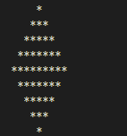
A2.
count = input("Enter factorial number: ")
factorial = 1
for i in range(1, int(count) + 1):
factorial = factorial * i
print("Factorial of " + str(count) + " is: " + str(factorial))
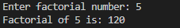
Conclusion
It demonstrates the use of loops in python and how efficiently apply mathematical concepts and patterns in python.

